# Government PU College Rajanukunte

# SCIENCE (PCMB, PCMCs)

Embark on a comprehensive scientific journey with our PCMB and PCMCS courses. The PCMB program integrates Physics, Chemistry, Mathematics, and Biology, offering a solid foundation for diverse scientific careers. Meanwhile, PCMCS combines Physics, Chemistry, Mathematics, and Computer Science, providing a well-rounded understanding of both physical sciences and computational principles. These courses prepare students for a future in science and technology, fostering a strong theoretical base alongside practical applications.

**Faculties:**

* Kartik Ankar ( Chemistry)

Head of scouts and guides Dept.- Govt PU College Rajanukunte

Education: MSC, BED,(PHD)

Date of Joining­ 24/10/2009

Teaching Experience- 15 Years

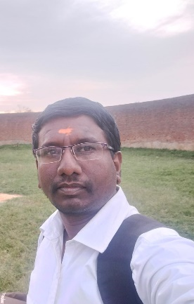

* N Veedavathi(MATHEMATICS)

Head of Controller of Examination (COE) GHS Rajanukunte

Education: MA, B.Ed

Date of Joining- 02-05-2011

Teaching Experience- 13



* Jayaramareddy R(PHYSICS)

Head of Bharat Seva Dal Dept.- Govt PU College Rajanukunte

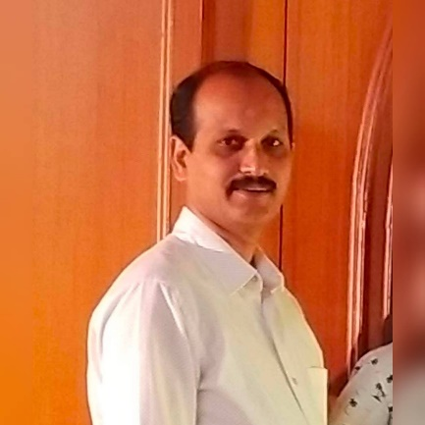Education: M.Sc, B.Ed

Date of Joining- 28/06/2013

Teaching Experience- 11 Years

* V Lokeshwari (BIOLOGY)

Head of Eco Club Dept.- Govt PU College Rajanukunte

Education:M.Sc, B.Ed

Date of Joining- 28/06/2013

Teaching Experience- 11 Years



* Bhoomika C M (Computer Science)

Education: BE – Computer Science

Teaching Experience- 05 years

* H Hussensabi(KANNADA)

Education: MA, B.Ed

Date of Joining- 22/08/1998

Teaching Experience- 26 Years

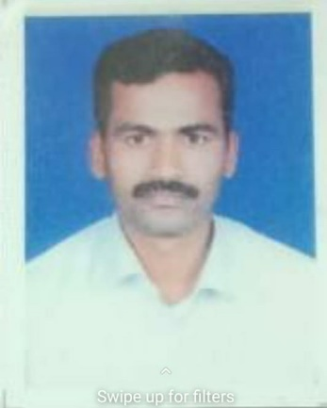

* Padmashree K(ENGLISH)

Education: M.A, MPhil, NET, B.Ed

Date of Joining- 01/07/2013

Teaching Experience- 7 Years

